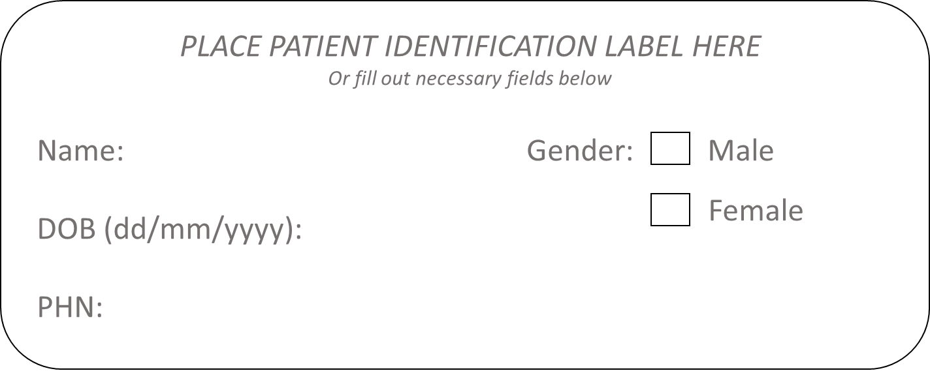
Todays Date:

Core Treatments
Treatment Option | Did you trial this treatment? | Approximate length of trial… |  |  |  |  | Provide specific details or examples of the treatment.
Education
Group Classes | - Yes  - No | - 0 – 3 weeks |  | - 3 – 6 weeks | - 6 – 12 weeks | - More than 12 weeks
Online Support | - Yes  - No | - 0 – 3 weeks |  | - 3 – 6 weeks | - 6 – 12 weeks | - More than 12 weeks
Counselling | - Yes  - No | - 0 – 3 weeks |  | - 3 – 6 weeks | - 6 – 12 weeks | - More than 12 weeks
Exercise & Physical Activity
Land based physical activity | - Yes  - No | - 0 – 3 weeks | - 3 – 6 weeks |  | - 6 – 12 weeks | - More than 12 weeks
Water based physical activity | - Yes  - No | - 0 – 3 weeks | - 3 – 6 weeks |  | - 6 – 12 weeks | - More than 12 weeks
Strength Exercises | - Yes  - No | - 0 – 3 weeks | - 3 – 6 weeks |  | - 6 – 12 weeks | - More than 12 weeks
Weight Management/Nutrition | - Yes  - No | - 0 – 3 weeks | - 3 – 6 weeks |  | - 6 – 12 weeks | - More than 12 weeks

Adjunct Treatments: Non-Pharmacological
Supports
Joint Protection | - Yes  - No | - 0 – 3 weeks | - 3 – 6 weeks | - 6 – 12 weeks | - More than 12 weeks
Walking aids | - Yes  - No | - 0 – 3 weeks | - 3 – 6 weeks | - 6 – 12 weeks | - More than 12 weeks
Adjunct Treatments: Pharmacological
Non-Prescription Treatments
Topical NSAIDs | - Yes  - No | - 0 – 3 weeks | - 3 – 6 weeks | - 6 – 12 weeks | - More than 12 weeks
Oral NSAIDs | - Yes  - No | - 0 – 3 weeks | - 3 – 6 weeks | - 6 – 12 weeks | - More than 12 weeks
Complementary Supplements | - Yes  - No | - 0 – 3 weeks | - 3 – 6 weeks | - 6 – 12 weeks | - More than 12 weeks
Prescription Treatments
Topical NSAIDs | - Yes  - No | - 0 – 3 weeks | - 3 – 6 weeks | - 6 – 12 weeks | - More than 12 weeks
Oral NSAIDs | - Yes  - No | - 0 – 3 weeks | - 3 – 6 weeks | - 6 – 12 weeks | - More than 12 weeks
Complementary Supplements | - Yes  - No | - 0 – 3 weeks | - 3 – 6 weeks | - 6 – 12 weeks | - More than 12 weeks
Injectables
Cortico-steroid | - Yes  - No | - 0 – 3 weeks | - 3 – 6 weeks | - 6 – 12 weeks | - More than 12 weeks
Hyaluronic Acid | - Yes  - No | - 0 – 3 weeks | - 3 – 6 weeks | - 6 – 12 weeks | - More than 12 weeks

